EXECUTIVE COMMITTEE

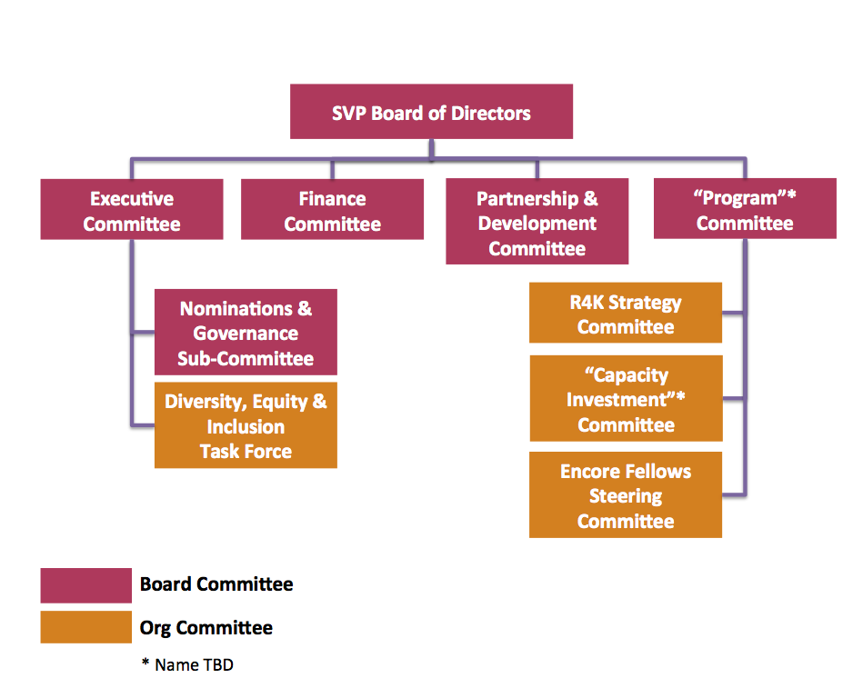

This Charter (the “Charter”) sets forth the duties and responsibilities and governs the operations of the Executive Committee (the “Committee”) of the Board of Directors (the “Board”) of Social Venture Partners Portland (SVPP or the Organization), a nonprofit corporation organized and existing under the Oregon Nonprofit Corporation Code.

I. Committee Purpose
The primary purpose of the Committee is to have a group of Directors authorized and able to act for the Board between regular meetings and in situations where an assembly of a quorum of the Board would be impracticable or impossible. The Committee also serves as an advisor to the CEO, providing consultation, support and guidance on an informal basis as requested from time to time.

II. Committee Meeting
The Committee will meet every other month or as necessary and appropriate at the call of the Chairman of the Committee or at the request of the CEO.

III. Committee Responsibilities
The committee’s primary duties and responsibilities are as follows:

- The Executive Committee shall present to the Board of Directors an annual evaluation of the overall performance of SVPP and the CEO.

- The Executive Committee is authorized to exercise the full power of the Board of Directors to act between meetings of the Board upon matters which, in the judgment of the Committee, are of such a nature as to require action prior to the next regular meeting of the Board but do not require calling of a special meeting of the Board of Directors.

- Any action taken by the Committee involving exercise of the powers of the Board of Directors shall be reported promptly to the Board, and ratified by the Board at the next meeting of the Board following such action.

The Executive Committee shall not have the power to:

- Amend SVPP Bylaws.
- Appoint or remove Directors, or the CEO.
- Adopt the operational budget.
- Take any action that is contrary to or a substantial departure from, the direction of the Board of Directors, or policy of Corporation.

IV. Amendment
This Charter shall not be amended except upon approval of the Board. Adopted by the Board on ___________.
Committee Chair: Kerry McClenahan

FINANCE COMMITTEE

This charter (the “Charter”) sets forth the duties and responsibilities and governs the operations of the Finance Committee (the “Committee”) of the Board of Directors (the “Board”) of Social Venture Partners Portland (SVPP or the Organization), a nonprofit corporation organized and existing under the Oregon Nonprofit Corporation Code.
I. Committee Purpose
The Finance Committee is a standing committee of the Board and is chaired by the Board Treasurer. The Committee is responsible for reviewing and providing guidance for the Organization’s financial matters. Specifically, the Committee assures internal risk management controls, independent audits, and analysis of financial highlights, trends and issues.
II. Committee Meeting
The Committee will meet every other month or as necessary and appropriate at the call of the Chairman of the Committee or at the request of the CEO.
III. Committee Responsibilities
The Committee’s primary duties and responsibilities are as follows:
- Provide direction to the Board for overall fiscal responsibility, including review of banking and all other finance-related contract services.
- Review and recommend to the Board for approval the Organization’s Risk Management Policies and on a monthly basis, review the Organization’s revenue and expenditures, balance sheet, investments, restricted funds, and all other matters related to SVPP’s continued solvency.
- Approve the annual budget and submit to the Board for approval.
- Review and recommend maintenance of a Board designated operating reserve in amounts appropriate to the operation of the Organization.
- Ensure the maintenance of an appropriate capital structure.
- Oversee the maintenance of organizational-wide assets, including prudent management of organizational investments.
- Ensure the preparation of an annual audit and/or audited Financial Statements, if required by the Board.
- Preparation of and submission to the Board for approval, all federal and state tax filings, with the assistance of external consultants, as required and/or deemed appropriate.
- Recommend and ensure implementation of financial policy decisions of the Board, including but not limited to Partnership revenues and contribution renewal processes, grant-making practices, and such other financial matters as deemed appropriate.
- Review and approve the Organization’s insurance guidelines, including (i) identity and rating of carriers, (ii) coverage for commercial general liability, directors and officers insurance, and workers compensation, and (iii) premiums.
- Provide support to Organization staff as needed.

Other Responsibilities
- Select and terminate the services of all outside financial advisors, consultants, banks, and investment banks. Review periodically SVPP’s significant commercial and banking relationships.
- Perform any other duties and responsibilities as the Board may deem necessary, advisable or appropriate for the Committee to perform, in order to maintain the integrity of SVPP’s financial wellbeing.
- Perform such other duties and responsibilities as the Committee deems appropriate to carry out its purpose as provided in this Charter.
- Report on a regular basis, but no less frequently than quarterly, to the Board Chair and the Board concerning SVPP’s financial affairs. Urgent and time sensitive matters shall be reported at the next regular or special Board meeting
IV. Committee Organization and Reporting Structure
The Committee reports to the Board Chair. The Committee is led by the Board Treasurer, who is also a member of the Board. The Committee includes a minimum of two Board members and two additional Partners of the Organization who are non-Board members. The Committee is appointed by the Board and Membership of the Committee is selected on an annual basis. (Members of the Committee may be appointed in successive year, without limit.) The Committee provides written reports about its meetings, recommendations and actions to the Board Chair and the Board on a regular basis – should we specify how often?.
V. Performance Evaluation
The Committee shall prepare and review with the Board an annual performance evaluation of the Committee, which evaluation shall compare the performance of the Committee with the requirements of this Charter. The performance evaluation shall also recommend to the Board any amendments to this Charter deemed necessary or desirable by the Committee. The report to the Board may take the form of an oral report by the chairperson or any other member of the Committee designated by the Committee to make the report.
VI. Amendment
This Charter shall not be amended except upon approval of the Board. Adopted by the Board on ___________.

Committee Chair: Greg Dufault

PARTNERSHIP AND DEVELOPMENT COMMMITTEE

This charter (the “Charter”) sets forth the duties and responsibilities and governs the operations of the Partnership and Development Committee (the “Committee”) of the Board of Directors (the “Board”) of Social Venture Partners Portland (SVPP or the Organization), a nonprofit corporation organized and existing under the Oregon Nonprofit Corporation Code.

I. Committee Purpose
The purpose of the Partnership & Development Committee is to cultivate passion and connection among the SVPP Partnership, while raising the funds required to achieve our community goals. We strive to build a resource base of money and talent that efficiently addresses barriers without delay and ensures SVPP’s vitality and sustainability.
II. Committee Meetings
The Committee will meet monthly or as necessary and appropriate at the call of the Chairman of the Committee or at the request of the CEO.
III. Committee Membership Structure
- Members sign up for roles within the committee that align to the advancement of various priorities, including: Connector, Fundraiser, Entertainer, Strategist and Community Advocate. Members are not expected to fulfill every role.
- Agree to a two-year term.
- Become familiar with and champion SVPP and the ready for kindergarten goal.
- Contribute an average of 5 hours/month to committee-related activities, such as: regular team meetings, meetings with prospects, Partners or donors, attending events or stewardship activities, reading/preparing materials, etc.
- Make a personally significant gift to SVP.

IV. Committee Responsibilities
The Committee’s primary duties and responsibilities are as follows:
- Develop Goals & Strategies.

- Create and implement goals and strategies – is this too redundant? that enrich the Partnership experience and position SVPP to achieve its fundraising targets with individuals.

- Develop and assess SVPP Partner recruitment and retention strategies and practices.

- Ensure Partnership and pro bono talent is maximized in order to serve R4K needs.

- Build awareness about SVP.

- Evaluate Partnership model and participant satisfaction.

- Recruit, Cultivate & Steward Partners & Donors – necessary to capitalize Cultivate and Steward?.

- Create quality touch points with and between Partners.

- Develop, advance and participate in SVPP events, meetings and activities focused on:

  - Building connections and community.

  - Creating shared learning opportunities.

  - Securing new Partners and donors to achieve annual growth targets.

- Evaluate effectiveness of the Partnership & Development Committee in its heft, agility and accountability.

VI. Amendment
This Charter shall not be amended except upon approval of the Board. Adopted by the Board on ___________.
Committee Chair: Jenn Bader and Barbara Francis

COMMUNITY PROGRAM COMMITTEE

This charter (the “Charter”) sets forth the duties and responsibilities and governs the operations of the Community Program Committee (the “Committee”) of the Board of Directors (the “Board”) of Social Venture Partners Portland (SVPP or the Organization), a nonprofit corporation organized and existing under the Oregon Nonprofit Corporation Code.
I. Committee Purpose
The purpose of the Committee is to provide strategic planning support and policy oversight to ensure focus and direction of SVPP programs and services.
II. Committee Meetings
The Committee will meet quarterly or as necessary and appropriate at the call of the Committee Chair or by specific request of the CEO.

III. Committee Responsibilities

The Committee’s primary duties and responsibilities are as follows:
- Develop and recommend to the Board of Directors policies and procedures governing the programs and services to be offered by SVPP to Partners and the public.

- Provide policy guidance and consultation for the CEO in setting priorities for programs and services.
- Establish policies and guidelines to assist the CEO in setting the fees to be charged for programs and services offered by SVPP.
- Establish policies and guidelines regarding to assist the CEO in considering fees for outside presenters and providers of services offered by SVPP.

- Establish policies and guidelines within which the CEO is authorized to enter collaborative arrangements with other organizations and providers of services.
- Ensure that SVPP:
  - Has in place a program evaluation process that measures the extent to which SVPP is achieving its mission.
  - Regularly uses the evaluation data to inform and continuously improve SVPP programs.
  - Uses evaluation data to educate the community (including funders) regarding the work and effectiveness of SVPP and its programs.

IV. Committee Organization and Reporting Structure
The Committee reports to the Board Chair. The Committee is led by a Board Director who is also a member of the Board. The Committee includes a minimum of two Board members and two additional Partners of the Organization who are non-Board members. The Committee is appointed by the Board and Membership of the Committee is selected on an annual basis. (Members of the Committee may be appointed in successive year, without limit.) The Committee provides written reports about its meetings, recommendations and actions to the Board Chair and the Board on a regular basis – does this need to be more specific?.

V. Amendment
This Charter shall not be amended except upon approval of the Board. Adopted by the Board on ___________.
Committee Chair: Kirt Nilsson and Heather Paulson

R4K STRATEGY COMMITTEE

This charter (the “Charter”) sets forth the duties and responsibilities and governs the operations of the Finance Committee (the “Committee”) of the Board of Directors (the “Board”) of Social Venture Partners Portland (SVPP or the Organization), a nonprofit corporation organized and existing under the Oregon Nonprofit Corporation Code.

Purpose:

Meeting: (Quarterly)
Responsibilities:
Committee Chair: Ellen M.

CAPACITY INVESTMENT COMMITTEE

This charter (the “Charter”) sets forth the duties and responsibilities and governs the operations of the Community Impact Committee (the “Committee”) of the Board of Directors (the “Board”) of Social Venture Partners Portland (SVPP or the Organization), a nonprofit corporation organized and existing under the Oregon Nonprofit Corporation Code.

I. Committee Purpose
The Community Impact Committee (CIC) is accountable for oversight of SVPP’s capacity-building investment portfolio, including stewardship of time, expertise, influence & dollars.
The goal is to ensure that our investments in programs, projects and/or organizations, individually and collectively make significant, measurable & sustainable contributions to our goal of ensuring all children are prepared for kindergarten.

II. Committee Meetings (Quarterly)
The Committee will meet quarterly or as necessary and appropriate at the call of the Committee Chair or by specific request of the CEO, and shall maintain minutes of all meetings, which will be distributed to the Board, preferably in advance of the next regularly scheduled Board meeting.

III. Committee Responsibilities
The Committee’s primary duties and responsibilities are as follows:
- Develop Goals & Strategies.
  - Create and implement goals & strategies that enable SVPP to make strategic & high leverage investments* that contribute significantly to the R4K goal.
    - Assess, influence and respond to evolving early childhood landscape.
    - Ensure alignment among SVPP’s capacity-building and system-level investments, as well as other funders.
    - Develop tool for qualifying organizations by impact and reach.
    - Employ tool to identify and invest in “key” players (leadership and/or orgs).

- Oversee & Evaluate Performance of Individual Investments & Portfolio.
  - Design and oversee a proactive & collaborative investment selection process.
  - Oversee portfolio of investments.
    - Determine key performance attributes that Investees will achieve by SVP exit (i.e., outcomes measurement, leadership & board governance)**
    - Define clear partnership goals, work plan with milestones & exit strategy.
    - Support & monitor relationship development with and among investees.
    - Conduct performance review of Investees (e.g., capacity-building progress, program outcomes) & portfolio** (R4K progress)
  - Drive continuous improvement of process.
  - Document and utilize evaluation findings & institutional knowledge of strategy and operational successes to inform improvements.
- Stewardship of Resources
  - Oversee engagement with Investees.
    - Recruit, train & provide ongoing support for Lead Teams, Partners & Fellows.
    - Identify & utilize external volunteers & consultants, as appropriate.
  - Manage financial investments.
    - Oversee SVP grant funding (at all stages, from year 1 to exit).
    - Attract next-stage growth funding.
  - SVP influence.
- Evaluate effectiveness of the CIC in its heft, agility & accountability.
IV. Amendment
This Charter shall not be amended except upon approval of the Board. Adopted by the Board on ___________.

Committee Chair: TBD

ENCORE FELLOWS STEERING COMMITTEE

This charter (the “Charter”) sets forth the duties and responsibilities and governs the operations of the Encore Fellows Steering Committee (the “Committee”) at Social Venture Partners Portland (SVPP or the Organization).
I. Committee Purpose
The Committee is a continuing committee chaired by the Encore Fellows Program Manager. The Committee is responsible for reviewing and providing guidance for the Encore Fellows Program (the “Program”). Specifically, the Committee advises the Program Manager about long-term strategies for developing the Program and short-term initiatives to improve program operations.
II. Committee Meetings
The Committee will meet quarterly or as necessary and appropriate at the call of the Committee Chair or by specific request of the CEO, and shall maintain minutes of all meetings, which will be distributed to the Board, preferably – is it necessary to say this, should it be required instead of preferable? in advance of the next regularly scheduled Board meeting.
III. Committee Responsibilities
The Committee’s primary duties and responsibilities are as follows:
- Provide advice to the Program Manager about trends in the Portland/SW Washington community with respect to potential retirees, work hosts, and sponsors.
- Review and recommend proposals and initiatives for developing the program, potential partnerships, and improving program operations.
- Advise the Program Manager on ways to integrate the Program with SVPP, both in terms of Fellows serving SVPP’s investees during their fellowships or as volunteers, and in terms of continuing relationships with SVP.
- Establish priorities for program operations, review the annual budget to be submitted to SVPP’s Director of Operations, and review Program performance.
- Assess and promote the continuing sustainability of the Program.
- Support to the Program Manager as needed.
- Perform other duties and responsibilities as the Committee deems appropriate to carry out its purpose as provided in this Charter.

IV. Committee Membership, Organization and Reporting Structure
The Steering Committee leverages the experiences, expertise, and insight of key individuals at organizations committed to promoting encore careers. Except for the Program Manager, Committee members are not directly responsible for managing Program activities, but provide support and guidance for the Program Manager. Thus, individually, Steering Committee members should:
- Understand the strategic implications and outcomes of initiatives being pursued through Program activities.
- Appreciate the significance of the Program for major stakeholders and represent their interests.
- Be genuinely interested in the Program and be an advocate for broad support for the outcomes it pursues.
- Have a broad understanding of encore career issues and approach being adopted.

The Committee includes:
- two (2) Partners of the Organization, one of whom preferably will be a member of the Board of SVPP;
- two (2) Fellows, one current and one an alumnus/alumna;
- one (1) work host;
- one (1) sponsor, corporate or philanthropic; two (2) representatives of community organizations associated with encore career opportunities, such the Institute on Aging at Portland State University.
The Committee is appointed by the CEO with input from the Program Manager. Membership of the Committee is selected on an annual basis. (Members of the Committee may be appointed in successive years, without limit.) The Committee provides written reports about its meetings, recommendations and actions to the CEO of SVPP.

V. Performance Evaluation
The Committee shall prepare an annual performance evaluation of the Committee, which shall compare the performance of the Committee with the requirements of this Charter. The performance evaluation shall also recommend to the Director of Operations amendments to this Charter deemed necessary or desirable by the Committee. The evaluation may take the form of an oral report by the chairperson or any other member of the Committee designated by the Committee to make the report.
VI. Amendment
This Charter shall not be amended except upon approval of the CEO of SVPP. Adopted on ___________.

Committee Chair: TBD

NOMINATION & GOVERNANCE COMMITTEE CHARTER

This charter (the “Charter”) sets forth the duties and responsibilities and governs the operations of the Nominations & Governance Committee (the “Committee”) of the Board of Directors (the “Board”) of Social Venture Partners Portland (SVPP or the Organization), a nonprofit corporation organized and existing under the Oregon Nonprofit Corporation Code.
- Committee Purpose

- The Nomination & Governance Committee is appointed by the Board of Directors (i) to identify and assist in recruiting outstanding individuals who qualify to serve as Board members and to recommend that the Board select a slate of director nominees for election by SVPP Directors at each annual meeting in accordance with SVPP’s Bylaws; (ii) to recommend directors for appointment to each Board committee; (iii) to review the performance of the Board and its committees and make appropriate recommendations; and (iv) to oversee SVPP’s governance guidelines and periodically re-evaluate such governance guidelines for the purpose of suggesting changes if appropriate.

II. Committee Membership
The Committee shall consist of at least two members and a maximum of five members. The members of the Committee shall be appointed and replaced by the Board on the recommendation of the then current Committee. The Board shall designate the Chairman of the Committee.

III. Committee Responsibilities

- The Committee shall actively seek, interview and evaluate individuals qualified to become board members for recommendation to the Board.

- The Committee shall have the power to hire legal, accounting, financial or other advisors as they may deem necessary in their judgment, without the need to obtain the prior approval of any officer of SVPP Board.

- The Committee shall have the sole authority to retain and terminate any search firm to be used to identify director candidates and shall have sole authority to approve the search firm’s fees and other retention terms.

- The Committee shall periodically review and assess the performance of the Board and its committees and report such assessment, including any recommendations for proposed changes, to the Board. The Committee should seek comments from each of the directors or committee members, as the case may be, with respect to such assessment.
- The Committee shall periodically review and reassess the adequacy of the Company’s corporate governance guidelines and recommend any proposed changes to the Board.

- The Committee shall make periodic reports to the Board regarding the Committee’s evaluation of the Board members, its committees and members thereof and the corporate governance guidelines of the Company.

- The Committee shall periodically review and reassess the adequacy of this Charter and recommend any proposed changes to the Board.

IV. Committee Meetings

The Committee shall meet at least two times per year. Minutes of each Committee meeting will be kept and filed with the Company’s Secretary.

V. Amendment
This Charter shall not be amended except upon approval of the Board. Adopted by the Board on ___________.
Committee Chair: Michael Philips, Director

DIVERSITY, EQUITY & INCLUSION
TASK FORCE

This charter (the “Charter”) sets forth the duties and responsibilities and governs the operations of the Diversity, Equity & Inclusion Task Force (the “DEI”) of the Board of Directors (the “Board”) of Social Venture Partners Portland (SVPP or the Organization), a nonprofit corporation organized and existing under the Oregon Nonprofit Corporation Code.

Purpose:
Responsibilities:
Meetings: (EOM):
Committee Chair: TBD

