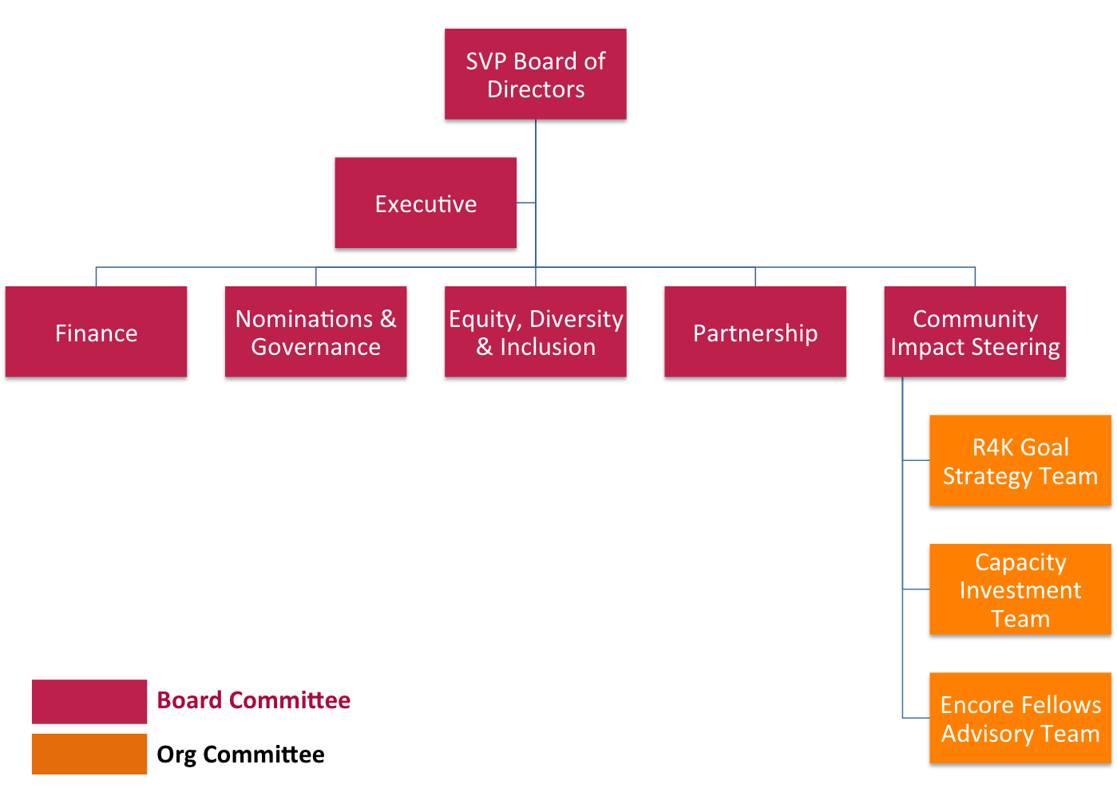
Proposed Committee Structure

BOARD COMMITTEES (Must be chaired by a Board member.)

EQUITY, DIVERSITY & INCLUSION COMMITTEE
Purpose: Prioritizing and implementing action steps that integrate EDI throughout SVP, being strategic with regard to sequence, timing, impact, and opportunity cost.
Frequency: Monthly
Chair: Carlo Delumpa

EXECUTIVE COMMITTEE
Purpose: Authorize a group of Directors able to act for the Board between regular meetings and in situations where an assembly of a quorum of the Board would be impracticable or impossible. The Committee also serves as an advisor to the Executive Director, providing consultation, support and guidance on an informal basis as requested from time to time.
Frequency: Quarterly
Chair: Board President, Kerry McClenahan

FINANCE COMMITTEE
Purpose: Review and provide guidance for SVPP’s financial matters. Specifically, the committee assures internal risk management controls, independent audits, analysis of financial highlights and operational budget review.
Meeting Frequency: Every other month
Chair: Board Treasurer, Greg Dufault

NOMINATION & GOVERNANCE COMMITTEE
Purpose: DRAFT: (1) Identify and assist in recruiting outstanding individuals who qualify to serve as Board members and to recommend that the Board select a slate of director nominees for election by SVPP Directors at each annual meeting in accordance with SVPP’s Bylaws; (2) to recommend directors for appointment to each Board committee; (3) to review the performance of the Board and its committees and make appropriate recommendations; and (4) to oversee SVPP’s governance guidelines and periodically re-evaluate such governance guidelines for the purpose of suggesting changes if appropriate.
Meeting Frequency: Monthly for six-month period each year (Spring
Chair: Michael Phillips

PARTNERSHIP COMMMITTEE
Purpose: The role of the Partner Vitality Team is to ROAR for SVP (Recruit, Orient, Activate, and Retain Partners)
Meeting Frequency: Every other month
Co-Chair(s): Barbara Francis and Nicole Simpson

COMMUNITY IMPACT STEERING COMMITTEE
Purpose: Provide direction and oversight of resource allocation for SVP’s community impact teams. Areas of responsibility include monitoring and evaluation of community impact, reporting to Board, recommending changes to policies, programs and strategies. The committee will function as a coordinating mechanism for the chairs of the following organizational teams: R4K Goal Strategy, Capacity Investment and Encore Fellows Steering.
Meeting Frequency: Quarterly
Co-Chair(s): Heather Paulson and Ken deLaski

ORGANIZATIONAL TEAMS (Need not be chaired by a Board member.)

R4K GOAL STRATEGY TEAM
Purpose: Engaging research and the community to advance SVP’s strategy for the R4K Goal. Develop knowledge of the primary mechanisms for improving kindergarten readiness for children, families, schools and communities (and specifically the needs and opportunities in the Portland metro area). Provide guidance to SVP’s committees and Board on investment, program and influence opportunities to achieve the R4K Goal.
Meeting Frequency: Monthly
Chair: Larry Fox
CAPACITY INVESTMENT TEAM
Purpose: Steward SVPP’s capacity-building investment portfolio to ensure that our investments in programs and projects operate with excellence to help reach our community goal.
Meeting Frequency: Monthly
Committee Chair: Kirt Nilsson

ENCORE FELLOWS STEERING TEAM
Purpose: Review and provide guidance for the Encore Fellows Program. Specifically, the Committee advises the Program Manager about long-term strategies for developing the Program and short-term initiatives to improve program operations.
Meeting Frequency: Quarterly
Committee Chair: TBD

