2017 INVESTMENT COMMITTEE

Information Package

SVP INVESTMENT COMMITTEE DESCRIPTION
Over a six-month period, the Investment Committee evaluates prospective investees in order to add new organizations to the SVP portfolio. The following provides an overview of the committee and the principles that guide the investment process.
Function and Structure
The Investment Committee represents all partners in choosing new investees. The committee is responsible for evaluating the organizational “SVP Fit” of prospective investees (see page 6 for information on SVP Fit).
The committee is chaired by a partner who has previously served on an Investment Committee. The committee is facilitated by the SVP Executive Director (ED), who also takes the committee’s final decision to the Board of Directors for ratification.
Each year’s committee will ideally include both new partner volunteers and some who have previously participated in the committee.
After completing the investment selection cycle, it is typically a committee member volunteers to serve as Lead Partner with the new investee. If one cannot be found from within the committee, the SVP ED will look to non-committee member partners.
After receiving an initial grant, the new investee will work with the Lead Partner and SVP staff to create a work plan, begin capacity development work, and enter the standard re-investment cycle for SVP investees, including annual evaluation by the Reinvestment Committee.
Learning Goals
Throughout the investment selection process, committee members will learn about the following:
- Non-profit Basics: What is a non-profit versus a charity? How do non-profits operate? What do their finances look like? What challenges do they face? What distinguishes a successful not for profit organization?
- Issue Area Basics: Committee members gain a broad understanding of issue areas related to SVP investment focus. This includes learning from both researchers and practitioners about exemplary programs, best practices, challenges, history and trends.
- Local Landscape: Committee members are exposed to and learn from many local non-profit organizations working in SVP’s investment focus. They learn about the depth and breadth of needs in Waterloo Region and who is working to meet these needs.

- Grant Making and Philanthropy: Committee members learn about good grant making practices, including procedures, research, criteria development, proposal evaluation and site visits. They also gain more understanding about their own interests and values.
- Group Funding: Committee members gain experience and skill in the dynamics of group decision making and funding as a group.
- Personal Learning: Committee members learn more about their own interests; what skills they have to offer non-profits

Time Commitment and Responsibilities
Committee members must be able to commit approximately 1-3 hours a month to full committee meetings (please see the Investment Committee Calendar). All committee members must sign a Confidentiality and Conflict of Interest Agreement (Appendix #1)
Responsibilities of each Committee member include participation in scheduled meetings as well as participation in the following “homework” functions, completed at the committee member’s convenience:
- On-line investigation of community issues
- Review of Letters of Interest & small team discussions
- Review of full proposals
- Site visits to finalist organizations (if necessary)

To be eligible to apply to SVP, organizations must have their management team based in Waterloo Region and the majority of its services focused within Waterloo Region. Organizations may serve a specific geographical area within the region, or the region as a whole.
At this time, SVP works with individual organizations and not with collaborative structures or networks of organizations. SVP is interested in learning how its capacity building model could be applied to collective action in the future.
*Note: an important part of our process is an Organizational Capacity Assessment which occurs once an Investee has been selected.
Appendix 1 – Confidentiality and Conflict of Interest Agreement
OUR APPROACH TO PHILANTHROPY

a) SVP partners make highly engaged investments of their time, expertise and money in community-based charitable organizations.
b) SVP aims to help educate and mobilize partners in order to enable and support lifelong, informed, engaged and inspired philanthropists within our community.
c) Through its investments, SVP aims to strengthen the longer-term effectiveness, sustainability and capacity of the organizations in which it invests.
d) SVP engages in focused philanthropy, meaning that on a regular basis, SVP partners select a particular area of focus for their investment activities.
e) The SVP investment assessment process engages partners in selecting an investee organization through which significant impact can be achieved with an innovative and strategic partnership between the investee organization and SVP.
f) The relationship between SVP and investee organizations initially involves a three-year commitment with the possibility of an additional one or two years. That three-year commitment is subject to positive annual reinvestment reviews.

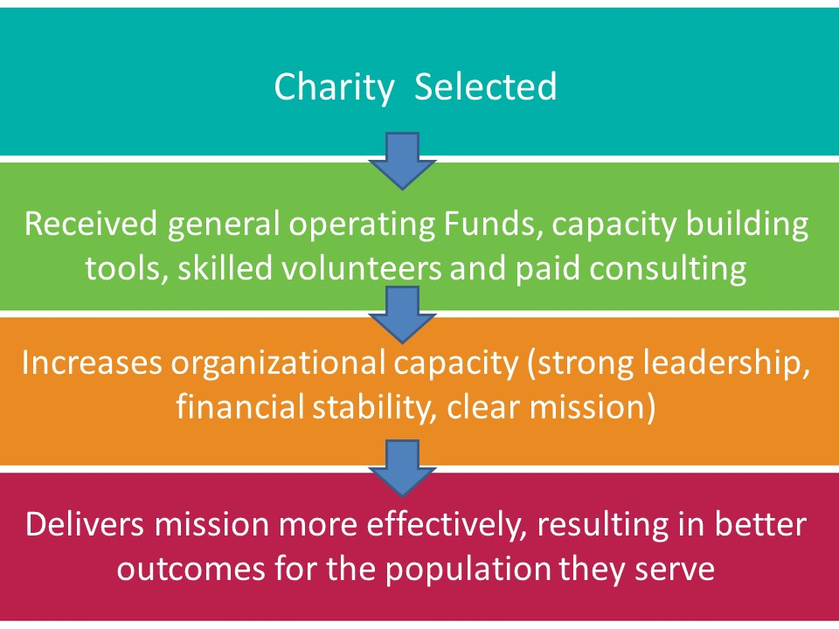
OUR GRANT MAKING PRINCIPLES AND PROCESS
Nonprofits have an obligation to seek new and even more effective ways of making tangible progress towards their missions, and this requires building organizational capacity. All too many nonprofits, however, focus on creating new programs and keeping administrative costs low instead of building the organizational capacity necessary to achieve their aspirations effectively and efficiently…This must change: both nonprofit managers and those that fund them must recognize that excellence in programmatic innovation and implementation are insufficient for nonprofits to achieve lasting results. Great programs need great organizations behind them.”
-Effective Capacity Building in Nonprofit Organizations,
Report for Venture Philanthropy Partners by McKinsey & Company

Why is capacity development important to SVP?
SVP is not only a philanthropic and grant making organization, but also a capacity development organization. We provide two types of direct support to investee organizations:
- Human capital for capacity development
SVP works with investee organizations to improve the overall capacity or effectiveness of the organization, allowing its impact to grow and thrive on a longer term, sustainable basis. We define organizational capacity building as:
- the development of core skills, management practices, strategies and systems to enhance ;
- an organization’s effectiveness, sustainability and ability to fulfill its mission.

We believe that stronger management, systems and infrastructure result in stronger organizations that can more effectively fulfill their mission.
Capacity building is not just about the capacity of a nonprofit today -- it's about the future. Distinct capacity building projects such as identifying a communications strategy, improving volunteer recruitment, developing a leadership succession plan, identifying more efficient uses of technology, and engaging in collaborations with community partners -- all build the capacity of a charitable nonprofit to effectively deliver its mission in the future. When capacity building is successful, it strengthens a nonprofit’s ability to fulfill its mission over time, and enhances the nonprofit’s ability to have a positive impact on lives and communities.

- National Council of Nonprofits

To achieve this, SVP works in partnership with non-profits. In addition to cash grants, SVP provides skilled volunteers, professional consultants (as needed and subject to budget availability), leadership development and management training opportunities.
SVP matches our partners’ expertise with the needs of our investees. By working together, our partners and investees develop a unique mutually beneficial relationship.

- General financial support for operational and capacity development initiatives
Investee organizations receive grants, which they can use for general operating support and capacity development initiatives.

SVP FIT
In September 2016, SVP adopted the following key investment criteria:
Current investment focus: Families, Children and Youth
SVP Waterloo Region would like to partner with a registered charity located in Waterloo Region that:
- Is committed to building their organizational capacity; can demonstrate how they have built capacity in the past and identify how they can continue to do so;
- Is ready for change and can articulate where they want to go and how to get there; must have an effective Board-Executive Director relationship where both are equally supportive of focusing on capacity building;
- Can demonstrate they have the time required to work with SVP;
- Is committed to furthering the community agenda of belonging and can outline how they apply a “lens” of belonging to their work as it relates the Vital Signs Report.
Additional Grant Recipient Requirements:

- Full time paid Executive Director
- Registered Charity
- Majority of programs serve Waterloo Region
- Head office located in Waterloo Region

We seek to partner with organizations that are “capacity-development ready”:
- Long term goals (3 years) for the organization and its programs, and ideas for how capacity building support can help amplify impact
- Self aware - understand organization’s strengths and challenges*
- ED and engaged board - receptive and supportive of SVP volunteer involvement over at least 3 years
- Financially stable (SVP doesn’t typically partner with organizations in financial crisis)
- Committed to measuring impact to achieve higher levels of effectiveness
- Value importance of building organizational capacity to achieve their mission
- Request skills and expertise that we feel matches our partner resources

CONFIDENTIALITY AND CONFLICT OF INTEREST
AGREEMENT

Confidentiality
SVP Waterloo Region’s (SVP) Investment Committee seeks to engage in honest and open dialogue on the pros and cons of each grant applicant and choose organizations that fit best with SVP’s model. We rely on and respect the knowledge and experience that others have in our community to effectively address community and social issues. We want to protect the integrity of our process and show respect for the information we receive from an organization, from experts in the community, and from each other. To that end, we require that funding discussions be held in strictest confidence.

Conflict of Interest

SVP partners, or a spouse or other immediate family member, are often active in the community and may volunteer, serve on boards or be employed by organizations submitting grant applications. This experience and knowledge may enhance the grant committee’s discussions around particular issue areas and organizations. However, SVP needs to maintain an open, competitive process where no one partner has, or can be perceived as having, undue influence over SVP’s funding decisions for an organization where they have a conflict.
In order to maintain the integrity of the process for the organizations being evaluated and to ensure every committee member feels comfortable sharing their views openly, SVP requires committee members to announce if they have a relationship with an applicant organization that may constitute a real or perceived conflict of interest. There is a conflict of interest when a committee member, or spouse and/or immediate family member:
- is a major donor of the application organization (5% or more of the organization’s income);
- currently serves on the Board or any ad hoc committees of the applicant organization
- is employed by the applicant organization;
- was/is involved in preparing the application.
- In the event a committee member isn’t clear on whether or not a conflict exists, a discussion with the Investment Committee Chair is the first step in assessing the situation.

Committee members who disclose a conflict of interest will adhere to the following rules during the grant committee process:

Those with a conflict of interest with any of the LOI applicants will be asked to excuse themselves from the review of all LOIs. If the organization with which they have a conflict of interest is invited to submit a full proposal, the committee member must step down from the Investment Committee. If not, the committee member may rejoin the committee at the proposal review stage.

I agree to honour and abide by the statements of confidentiality and conflict of interest described above.

_________________________________________________________________
Partner Name / Signature

_________________________________
Date

Organization(s) in conflict

