Social Venture Partners Boulder County
Report on Impact in Capacity Building
September 2014
Report compiled by: Jennie Arbogash, Executive Director

Background
Social Venture Partners Boulder County (“SVP”) catalyzes and supports the collective action of community members through leveraging human and financial capital to enable local nonprofits to excel in meeting community needs. This dual mission develops philanthropy and volunteerism and builds the capacity of nonprofit organizations (Investees).

This report pertains to SVP’s effectiveness in building capacity among its Investees. SVP builds capacity through technical assistance, cash grants, and connecting Partners with nonprofits as volunteers. As a learning organization, SVP seeks to continually assess its progress and improve its performance. In assessing our impact in capacity building, we have prioritized these outcomes:
- Investee satisfaction with SVP
- Value added by SVP Partners
- Impact of capacity gains on program effectiveness

In summer of 2014 we administered tools to gather data on Investee outcomes and received responses from 4 of 4, or 100%, of Investees who had received investment for 1+ years.

Methodology
The following data collection tools were used to generate this report:
- The Investee Survey, administered June-July, generated qualitative information related to Investee satisfaction and the perceived value of volunteer assignments, and quantitative data related to the value-added of SVP Partners.
- The Most Significant Change Tool, administered in July, generated information about SVP’s Impact on Program Effectiveness.

Limitations to the Data
The data that follows paints a meaningful and important portrait of SVP’s impact in its work in building nonprofit capacity. It is nonetheless important to acknowledge several aspects of the research methodology that may impact the data, particularly as it relates to the Investee survey.
- Although the information provided by Investees was confidential, there is an inherent bias in surveys administered to grantees by funders. To minimize this bias, SVP administered the survey after re-funding decisions had been made and announced.
- The quantitative data related to calculating value added by SVP Partners are estimates by Investees. SVPI has reviewed the Investee data, but there is a degree of judgment in these numbers and they should be viewed as estimates.
- The data related to increased capacity gain and/or stories of significant change is subjective and was provided by Investees without independent review or verification.

General Information about Respondents:
- Two of the four Investees recently completed their 1st year of investment from SVP; one completed their 2nd year of investment, the other completed their 3rd and final year;
- The most recent cash grant to these Investees by SVP averaged approximately $21,250.

Key Findings on Impact

Investee Satisfaction with SVP
Tracking Investee perceptions of SVP is important because of the relationship-intensive nature of the affiliation. SVP prides itself on its transparency with Investees and its high level of engagement requires a strong foundation of trust. As such, a high degree of Investee satisfaction with the SVP relationship is a prerequisite for any meaningful capacity building work.

Overall Satisfaction
Overall, 100% of SVP Investees characterized their relationship with SVP as excellent.
Satisfaction according to the specific criteria of Approachability, Responsiveness, and Knowledge was as follows:

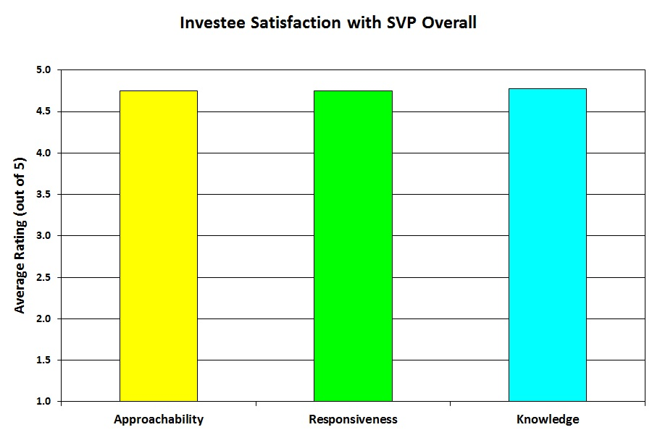

Satisfaction with SVP Partners and Staff
Satisfaction with SVP Lead Partners, Other Partners and Staff was as follows:

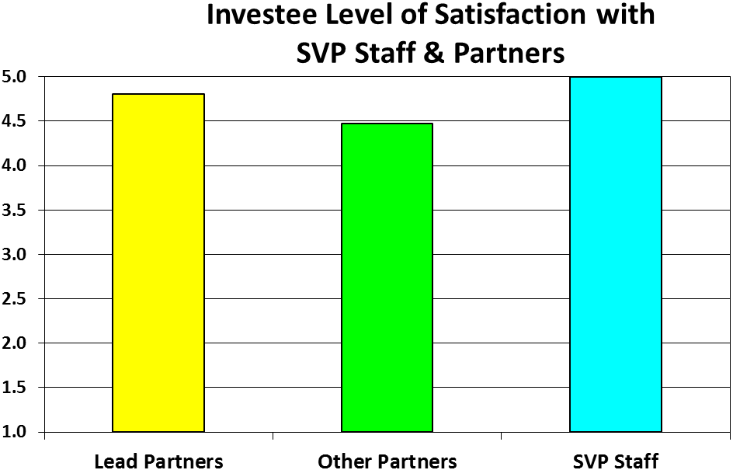

Satisfaction According to Different Forms of SVP Assistance
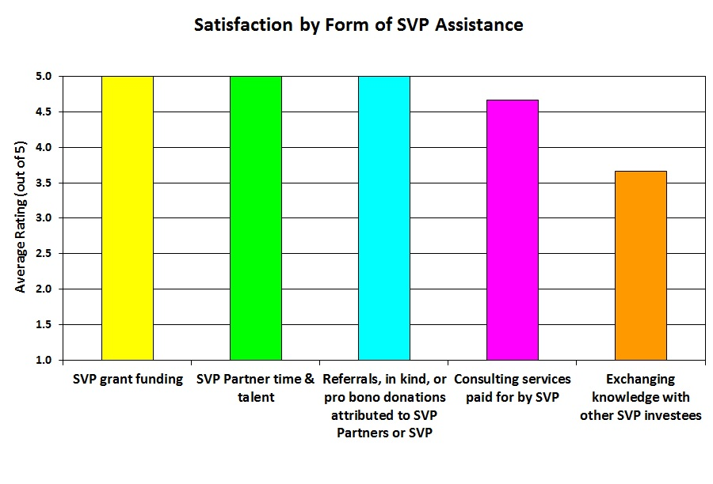
SVP asked Investees for their perception of the value of the different forms of assistance that they received. They were asked to rank their satisfaction with the following types of assistance: 1) cash grants, 2) Partner time and talent, 3) Referrals, in-kind or pro bono donations by Partners or through SVP, 4) consulting services paid for by SVP, and 5) exchanging knowledge with other Investees. The three rated highest by Investees were:
- Cash grants (average rating of 5.0)
- Partner time and talent (average rating of 5.0)
- Referrals, in-kind or pro bono donations by Partners or through SVP (average rating of 5.0)

Satisfaction with Partner Volunteers
SVP works with Investees to identify the particular areas of capacity it needs to develop, and then provides targeted resources to strengthen those areas. SVP asked Investee for their perceptions of value of Partner support for different areas of capacity building. They were asked to rank their satisfaction with the following types of assistance:

Mission, Vision, Strategy and Planning
Outcomes Measurement and Evaluation
Human Resources,
CEO/ED/Senior Management Team Leadership
Information Technology
Financial Management
Fund Development
Board Leadership
Legal Affairs
Marketing, Communications and External Relations

The areas where Investees reported receiving the most value were:
- Financial Management (5.0)
- Outcomes Measurement & Evaluation, Human Resources, and Board Leadership (4.7)

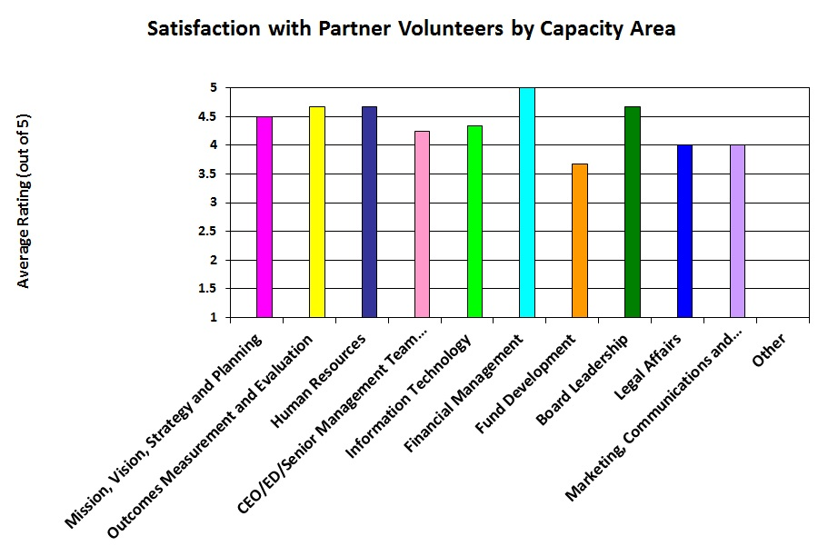

The table included in Appendix A provides more detail about the number of volunteer assignments and perceived value for each capacity area.

Value Added by SVP Partners
SVP’s strategy for building capacity is to provide a complete package of money, professional-level volunteers (Partners), consultants and networking opportunities to its Investee organizations.

In fact, the cash grants are only a small portion of the value that Investees gain by being part of SVP. Through the Investee survey, we attempt to quantify the value added by SVP Partners by asking Investees for information about the following:
- Partner volunteer time for strategic volunteer projects (we did not include Partner time dedicated to tutoring or mentoring).
- The new (first time) cash donations made by individual SVP Partners (as opposed to the SVP organizational grant).
- The new (first time) cash donations or grants received based on referrals or contacts from individual Partners.
- The in-kind benefits received based on referrals or contracts from individual Partners (for example, a Partner used their connections to negotiate pro bono printing services valued at $1,000).

A summary of the value added by SVP Partners across all responding Investees is as follows:

Value Added by SVP Partners
Volunteer Time (1,729 hours @ $100/hr) | $172,900
New (first time) cash contributions from individual Partners | $21,390
New (first time) cash contributions from Partner referrals | $10,000
In-kind contributions from Partner referrals | $3,500
Total | $207,790

From June, 2013, to May, 2014, the total value added by SVP Partners was approximately $208,000. During this same period, cash grants to Investees totaled $77,500. This means that the value added by SVP Partners was almost triple (2.7X) the value of cash grants!

Impact on Programs and Community
The effort SVP has made to strengthen the organizational capacity of its Investees has led to significant improvements in program effectiveness and social benefit. Although it is difficult to quantify these social gains, we have asked Investees to document stories of the most significant change that they have experienced in their organizational capacity as a result of their relationship with SVP. A story that best exemplifies the type of change that SVP is trying to promote is found below. The story is printed as submitted by the Investee.

Slow the Flow by Michelle Barnes, Interim Executive Director, Center for ReSource Conservation
At the Center for ReSource Conservation (CRC), we were used to getting by with what we had. But we knew we needed to change that approach and embrace capacity building in order to be able to grow our key programs and increase our impact. Specifically, our Slow the Flow water audit program had been running successfully for the past 7 years, but we couldn't scale it any more without a technology overhaul. As one of our flagship offerings, we are well known in the water community for this program as it truly puts conservation into action. But, it was figuratively duct-taped together and was totally reliant on the knowledge of just a few employees.

Slow the Flow is delivered by CRC in partnership with 25 water municipalities. Our technicians go to a residence, business or multi-unit housing project and evaluate the health of the lawn, the current sprinkler/watering system, and recommend the optimum system for a healthy yard with an eye to water conservation. We even program sprinkler systems and change out sprinkler heads. Our technicians were spending about 2 hours per home and we conducted over 2500 audits a summer. But demand was growing and we wanted to expand the program and also reduce the months of paperwork and reporting that followed each season. We just couldn't get where we wanted to be from where we were. We consulted with our SVP Lead Partner, Frank, and he brought a few Process and IT experts to help us get started.

We began by process mapping the entire step by step system we were currently using. Lots of flip charts and graphs were made and 3 SVP partners lent us their expertise in this exercise. We all studied them and found key areas in which we could streamline or completely change a step in order to make things more efficient. When you are used to doing things a certain way for years, it's really hard to change without outside support like we received from SVP. Then came the hard work of mapping out a new process and writing an RFP to hire a technology firm to create software to automate Slow the Flow. That's when SVP Partner Tim showed us his magic. Not only did he write the RFP with us, but he educated us on what we needed and why and helped review proposals. We selected a firm, wrote a big check and the coding began. He continued to consult with us and the software development firm throughout the process. It was a very large financial investment for us and we needed support and advice to help us keep this project on task and on budget.

8 weeks later, we began field testing the software. In addition to being able to generate reports on the fly, we were able to move off our paper-based system and supply our 15 technicians with IPADS to use in the field. We were able to decrease the time it took to do an audit to 90 minutes and greatly increase the quality and timeliness of our feedback to the homeowner. Our field staff loves their IPADS as they also get their schedule uploaded for them each night. The results: happy homeowners, auditors, staff, and greatly improved results. And, our key staff can take a vacation without worrying that the program can't survive without their constant handholding. Our impact has grown and we are extremely proud of our technology that positions us for growth. When Tim stops by our office we all lavish him with thanks as this project would never have happened without his guidance, expertise and collaboration. Thank you SVP!

Appendix A
Partner volunteer time for strategic volunteer projects

 | Number of Volunteers | Number of Hours
Mission, Vision, Strategy and Planning | 7 | 170
Outcomes Measurement and Evaluation | 14 | 186
Human Resources | 8 | 232
CEO/ED/Senior Management Team Leadership | 6 | 172
Information Technology | 7 | 258
Financial Management | 6 | 105
Fund Development | 7 | 119
Board Leadership | 9 | 144
Legal Affairs | 6 | 37
Marketing, Communications and External Relations | 5 | 211
Other | 11 | 95
Total | 86* | 1,729

*Some Partners may have volunteered for more than one project, thus the 86 volunteers is not unique individuals.

Information providing more specific information about these limitations and the measures taken to minimize them is available through SVP.
Approachability – The investee staff knows how to contact the Partner/staff/lead; feels comfortable contacting; feels receptiveness to their questions or feedback Responsiveness – The investee staff feels that the Partner/staff/lead replies in a timely way; the response is useful or thoughtful; and that the Partner/staff/lead demonstrated openness to the investee staff’s feedback Knowledge – The investee staff feels that the Partner/staff/lead is able to offer resources or ideas in response to their questions or request for information; that the Partner/staff/lead reflects understanding of their organization's mission and needs
The value was calculated using a market-based uniform rate of $100 per hour. Although market rates vary according to type of project, we chose a single rate at the low end of the range ($75-$150) to maximize ease and reliability of data collection.

